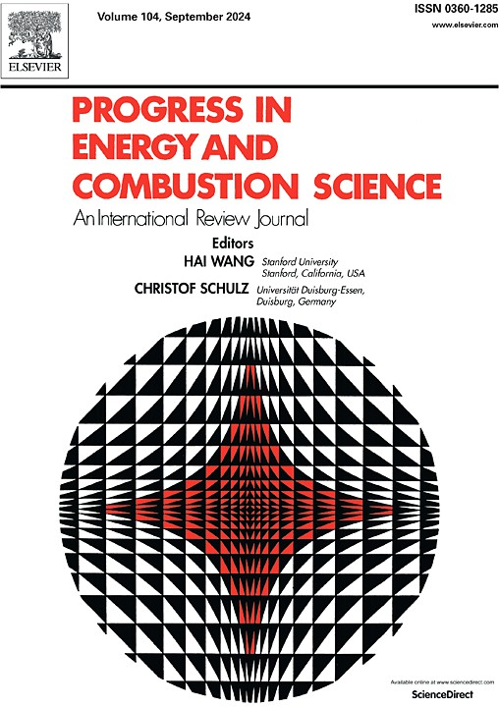

Proposal for a review article in Progress in Energy and Combustion Science (PECS)
Scope
PECS publishes review articles on most aspects of energy and combustion science. Each article provides a comprehensive in-depth overview, evaluation, and critical discussion to synthesize the current understanding of scientific research with strong potential for impact on solving the technical challenges associated with climate change and the transition to sustainable energy. Building on a proud tradition in combustion, the journal publishes articles by internationally recognized authors in all aspects of thermal-fluid science and engineering; chemical science and engineering; energy-focused developments in materials and related fields that explain how advances in research can help solve these challenges, spanning the mitigation of emissions from combustion and conversion of fuels, production and consumption of biofuels and e-fuels, and other renewable energy sources. The relevant research methods in this context, such as experimental, theoretical and simulation approaches, are also important topics that can be covered
Each volume contains a number of specially commissioned review articles that provide the reader with an organized and concise survey and scientific discussion of the topic. While they should not be unnecessarily long, the length of the articles allows the authors to discuss their subjects more comprehensively than is possible in papers reporting original work. These reviews provide an opportunity for researchers to become well informed in fields other than their own. They are useful to students seeking a comprehensive review and bibliography of a particular subject, to engineers working in governments or industry seeking practical solutions and to policy advisors seeking insight into emerging technologies.
Reviews are by invitation of the editors only. For proposing a topic for a review article, please fill in the below information and submit via Editorial Manager (www.editorialmanager.com/pecs) in as “Proposal”. Once the editors decide to invite you to submit your full paper, you will receive an invitation that enables you to submit a full article through the same website.
Please make sure that all information provided is legible in the pdf that is generated during submission. Note that all information is mandatory.
Suggested title
All suggested authors and affiliations (more information required below)
Abstract describing the relevance of the topic and overlap with the scope of PECS (one page)
Timeliness of the review, explaining why this review is needed relative to existing review articles and describing your unique approach
Twenty key papers in the field of your suggested review. Please provide title, all authors, bibliographic information and DOI hyperlink. This list can include your own work, please mark own work by bold face
Suggested table of contents, providing enough detail for us to understand your planned approach

Author information: Submission to PECS is by invitation from the editor; invitations are issued to experienced, recognized experts in their field who in most cases acts as the first author. We expect that all authors have significantly contributed to the field of their review. Note that changes to the author list after submission are only possible on request and based on detailed justification.
Please provide the following information for all authors (copy and paste this table for each author).
Name
Status
Affiliation
Relevant key expertise
Institutional email
Institutional website
Hyperlink to Scopus or Google Scholar
Number of peer-reviewed publications during the last two years
10 most important publications in the field of the planned article (with title, all authors, bibliographic information and DOI hyperlink) | 1.
 | 2.
 | 3.
 | 4.
 | 5.
 | 6.
 | 7.
 | 8.
 | 9.
 | 10.

Before you submit, please read the following statements.
PECS is a review journal by leading specialists in a given field to synthesize current understanding of that field. Such a review should include the state-of-the-art and pertinent history relevant to the present status on a given subject. It should not contain original material from the author(s), other than new interpretations of existing results; it may include the findings (published elsewhere), of the author(s), together with a discussion of the contributions of all other authors who published in the subject in the recent past. Ideas previously expressed by the invited authors are appropriate for inclusion, but self-plagiarism is not permitted. Most

important is the value added by the authors of the review manuscript, not only through stating the facts, but augmenting their interpretation by explaining, e.g., why some models have succeeded and others have not, or why some experiments give reliable results and others do not, or why some concepts are viable and others are not. It is also very desirable to present a clear analysis regarding future research needs.
A PECS review must be more than a series of statements like: “So and so did such and such, and found something [ref].” It must be more than a list of references and tables of data. A PECS article must be a comprehensive and in-depth review of the topic and must teach the reader something that they may not have learned had they read every one of the cited references. It is the duty of the PECS author to establish links between various aspects of the cited work, to synthesize it so as to teach the reader something new, and to provide a CRITICAL review of the research, pointing out controversies and taking a stand to point out issues in the literature.
PECS is primarily a scientific journal – its main emphasis is not on economics or on technology, nor on aspects relating to a particular area or country. However, reviews of tools, methodologies and results of techno-economics of energy technologies are relevant. Moreover, authors are encouraged to add sections on TEA to their articles whenever appropriate.
Excluding references, the length of the papers is typically less than 100 manuscript pages (11 pt, 1.5 line spacing, and figures embedded in readable format). Please contact the editor in case this is not sufficient in your case although, under almost all circumstances, papers should not exceed 150 manuscript pages and 300 references. Despite this allowance for sufficient length to cover a subject comprehensively, papers should still be concise and well organized to allow the information to be readily found.
Please be aware that – prior to review – all manuscripts are screened for plagiarism/self- plagiarism.
Further information can be downloaded here: http://www.elsevier.com/journals/progress-in- energy-and-combustion-science/0360-1285?generatepdf=true

